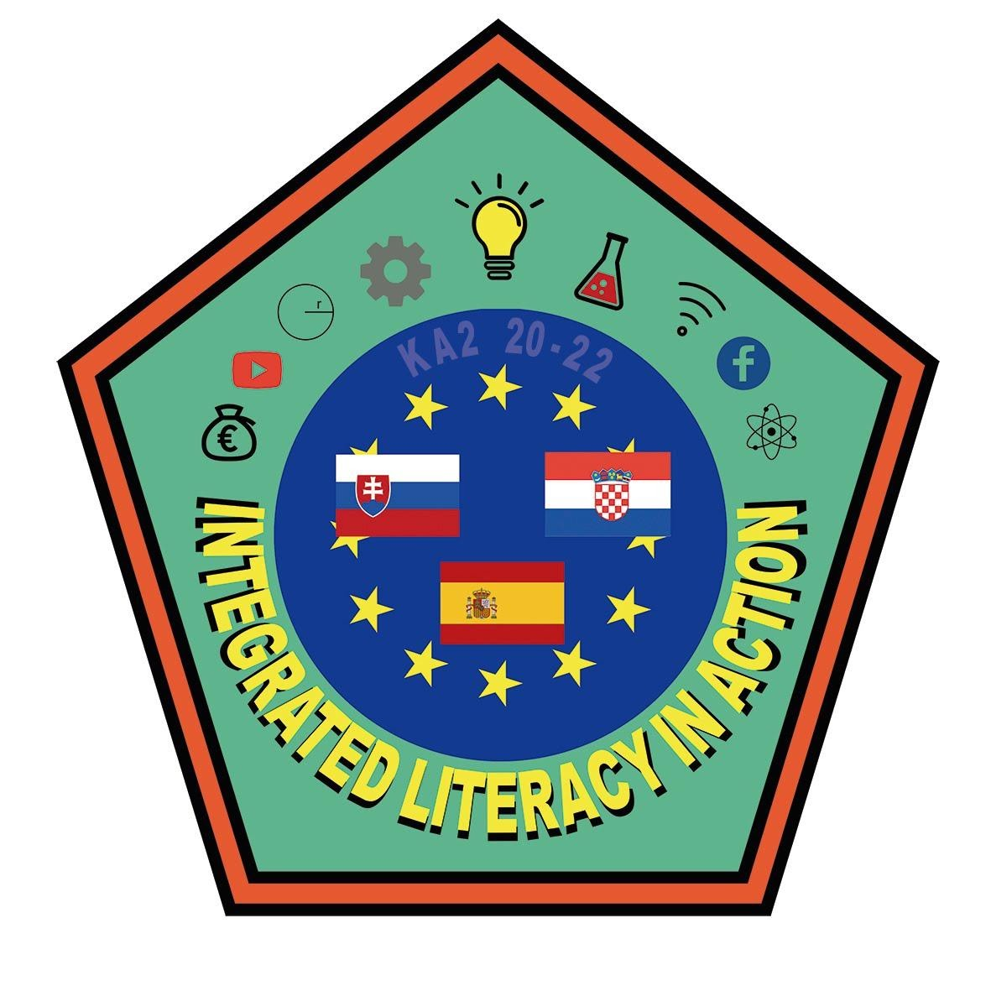
II. Gymnasium, Split
X. Gymnasium „Ivan Supek“
Gymnázium Pavla Jozefa Šafárika
IES Eras de Renueva

Integrated Literacy in Action – ILA

Project Identification No. 2020-1-HR01-KA229-077789

PROGRAMME

Module 4 – Mathematical Literacy
May 16th - 20th 2021
II. Gymnasium, Split
Ulica N. Tesle 10, Split, Croatia

DAY 1 – May 16th | Participants – ALL
9:15 am – 9:20 am | Opening  Mrs. Ivanka Kovačević, Headmistress, II. Gymnasium, Split  Anamarija Brzica, project coordinator
9.20 am – 9.30 am | Warm-up activities – getting to know each other
 | Participants – students and mentors | Participants – Expert Teachers
9.30 am - 12.30 pm | Workshop  Forking our way through Math menu  Pre-work activities presentation + workshop  Sanda Ilić, prof. | Open class 1  Integrated Curriculum
12.30 pm - 13. 15 pm | Lunch break
13.30 am – 14.30 pm | Workshop  Environmental impact on food production and consumption  Ana Pavičić Lešić, prof. | Open class 1  Integrated Curriculum
Participants – ALL
17.30 – 19.00 pm | Guided tour - Split
DAY 2 - May 17th | Participants – students and mentors | Participants – Expert Teachers
9.30 am – 12.15 pm | Math FTW workshop  Sport in Split: an overview  Sports and Statistics  Math – Count On Me  Karmen Šesnić, prof  Dina Spahija, prof | Open class 1  Integrated Curriculum
12.30 pm - 13. 15 pm | Lunch break | Lunch break
 | On the move workshop
13.30 am – 15.00 pm | Workshop  Karmen Šesnić, prof. | Open class 1  Integrated Curriculum
Participants – ALL
17.00 – 19.00 pm | Escape room: Let’s play with math!  Sanja Vitaljić, prof  Dina Spahija, prof.

DAY 3 – May 18th |  | Participants – ALL
 |  | Participants – students and mentors |  | Participants – project coordinators | Participants – Expert Teachers
9.00 am – 10.00 am |  |  |  | Project coordinator meeting
10.00 am - 12.30 pm |  | Workshop  How the real world functions  Demographics: shaping the future  Sanja Vitaljić, prof  Marin Borzić, prof |  |  | Open class 1  Integrated Curriculum
12.30 pm - 13. 15 pm |  |  | Lunch break
13.30 am – 14.30 pm |  | Workshop  Demographics: shaping the future  Presentation of the results |  |  | Open class 1  Integrated Curriculum
 | Participants – ALL
17.30 – 19.00 pm |  |  | Visit to Meštrović Gallery

DAY 4 – May 19th | Participants – ALL
09.00 – 19.00 | Field trip – The island of Brač  Stonemasonry workshop – Jakšić Gallery

DAY 5 – May 20th | Participants – ALL
 | Participants – students and mentors | Participants – Expert Teachers
10.00 am - 12.30 pm | Joint activities: Expert teachers and students  Evaluations – Certificate ceremony | Open class 1  Integrated Curriculum
12.45 am – 13.45 pm | Lunch break
Participants – ALL
16.00 – 19.00 pm | Farewell  PUB QUIZ

